**ARM/AMS Dimension data synchronisation**

Materialised view data replication option can be used for keeping the iHub/AMS dimension data in sync. The MV approach will capture the changed data (delta) on the iHub base tables. Whenever the refresh operation is invoked on the AMS materialised views, changed data will be extracted from iHub and applied to AMS dimension tables.

The MV refresh operation can be integrated with the cube re-build process to ensure that all latest dimension changes will be taken into consideration for the cube re-build. 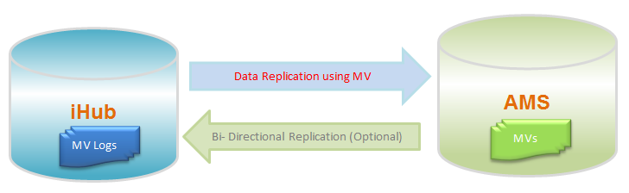

**Steps required for implementing MV replication.**

1. Create MV log in iHub database for each dimension base table: This enables the capture of changed data on the base table.

*CREATE MATERIALIZED VIEW LOG ON TMAP_ARM_VAR WITH PRIMARY KEY;*

1. Create MV for each table in AMS: The AMS MV will be synced with the content of iHub base dimension table after every refresh.

*CREATE MATERIALIZED VIEW TMAP_ARM_VAR*

*BUILD IMMEDIATE*

*REFRESH FORCE*

*WITH PRIMARY KEY*

*AS SELECT * FROM TMAP_ARM_VAR@IHUB;*

1. Invoke MV API to propagate the changes applied to iHub dimension since the last refresh to AMS.

*BEGIN DBMS_MVIEW.REFRESH('TMAP_ARM_VAR','FAST'); END;*

**Advantages**

1. Dimension sync can be integrated with cube re-build process.
2. MV approach is an all-in-oracle solution; dependency with Informatica layer for AMS cube build process for modelled data will be removed.
3. It will be faster as only delta records will be replicated to AMS.
4. Development and ongoing maintenance will be quicker and simpler.